Answer 3
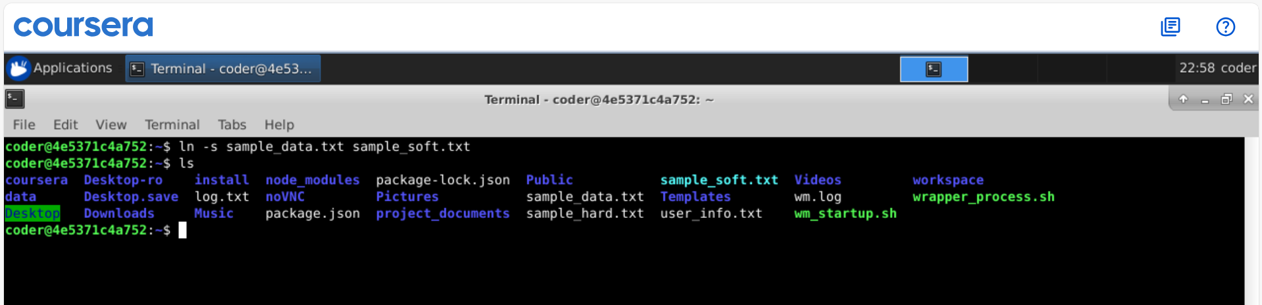
Explanation: By using ln command with -s option we can create a soft link. This has the same way provide source file first followed by the new name for the soft link.

